Marking and categorizing oocytes

08-may-2025

This project allows automatic and manual measurements of oocyte cells.

Resulting parameters are cell size and elliptical aspect ratio. Size

is visualized by a red line indicating the diameter of equivalent circle with same area.

A category (0..9) can be added manually, and is visualized by the "hand of a clock".

You can get statistics of any subset of objects that meets a combination of properties

***A - Install ObjectJ plugin***

- If not done yet, install objectj_.jar from <https://sils.fnwi.uva.nl/bcb/objectj>

- Move objectj_.jar into the ImageJ plugins folder by

dragging it into the ImageJ main window- so it will be saved in the correct place

- optionally, choose menu Plugins>ObjectJ

- Now the menu "ObjectJ" should appear between "Analyze" and "Plugins"

- If already installed, ObjectJ can be upgraded via: menu ObjectJ>Project>Update ObjectJ

***B - Download Sample Images and .ojj project file***

- [Download](https://sils.fnwi.uva.nl/bcb/objectj/examples/oocytes/oocytes-download/) "Oocyte-Samples" containing two sample images

- Download project file (currently 'Oocytes-35d.ojj') and move it into the project folder " Oocyte-Samples "

- Drag the .ojj file into the ImageJ main window to

open this project, wait until the project window

appears and shows the panel for "Linked Images"

(Alternatively, choose menu ObjectJ>Open Project..).

- Drag&drop the image files to be measured from the project folder

into the panel 'Linked Images', or click button 'Link All'

***C - Usage***

**1. Automatic marking of cells**

- choose menu ObjectJ>Mark Oocytes...

- In the dialog, if ‘Threshold’ is set to zero, you are asked to

threshold each image interactively, 1= automatic and >1 uses that value.

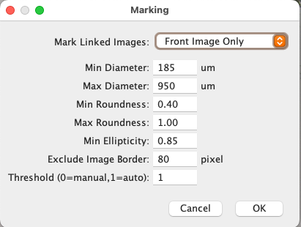

**2. Categorize any marked cell**

- Locate the cursor above a marked cell and press

key 0..9 for category. Cell will obtain that category as hand of a clock,

e.g. 4 o'clock means category 4.

**3. Kill a marked cell**

Position cursor above a cell an press key **‘K’**.

Alternatively, activate in ObjectJ>Tools the ‘pistol tool’.

**4. Mark an elliptical cell manually:**

ObjectJ tool **"V**" nust be activated ( press key **‘V**’ once or twice)-So that

Click and drag along a line A-B to follow the cell’s major axis.

After releasing the mouse button, a circular roi is shown.

Now move the cursor back towards the cell’s center to decrease the ellipse’s minor axis

Press key 0..9 to assign a category to the elliptical roi

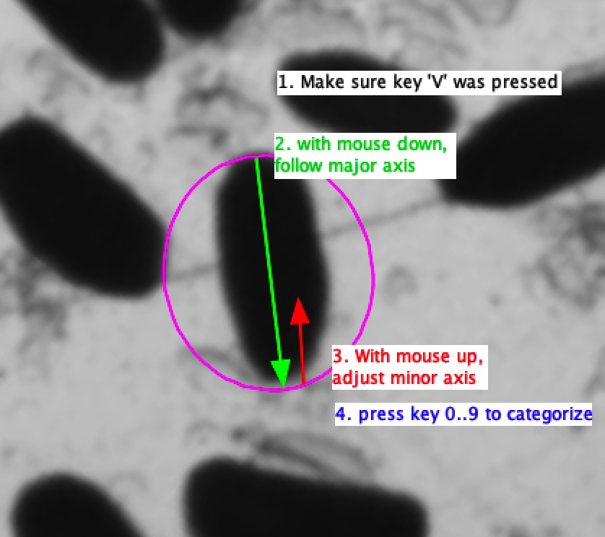

**5. Mark a cell with fixed diameter**

Make the floating circle visible above a small cell (if necessary press key **V** once or twice),

Press key 0..9 to define thecategory:

A line of fixed length (here 185 um at 45 deg) is used to mark the existence of such a cell.

Cell will be categorized like described above

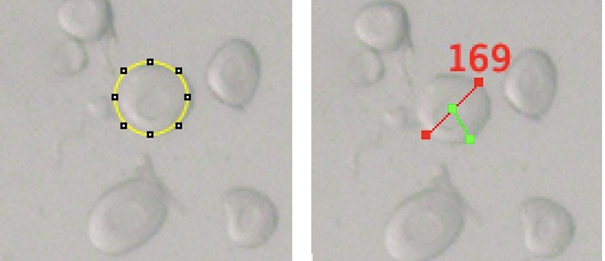

Floating circle before (left) and after categorizing with key "5" (right)

**6. Show/Hide Ellipses [E]**

Shows or hides the elliptical contours of marked cells.

**7. Categorize Uncategorized cells...**

You can set a default category to all objects that have no category yet.

This is done in all linked images.

Choose ObjectJ>Categorize all uncategorized cells...

Note: you cannot automatically undo this action!

**8. Results**

Choose ObjectJ>Show Project Results

to display numeric results. The following columns are implemented:

Dia equivalent diameter in um

Cat category 0..9, or -1 if uncategorized, or empty for fixed diameter

Roundn. same as Minor/Major (range 0..1)

Ellipt. ellipticity= ellipse perimeter/actual perimeter

(range 0..1, or empty for manual marking)

Minor minor axis (um)

Major major axis (um)

Area3 area (unit is 10^3 um^2 for convenience)

**9. Saving**

Periodically save the colored markers via menu ObjectJ>Save project.

(Note that menu "File>Save" only would save an image, not the markers)

**10. Mark your own images**

- Once the described sample project works satisfactory, you can save an empty copy

of the project file via ObjectJ>Project File> Save an Empty Copy.

- The empty copy contains all internal structure and macros, but no markers or linked images.

- Link your images via ObjectJ>Linked Images> Link Image from project Folder

- Make sure your linked images are scaled correctly (eg pixels per um)

**11. Notes**

- cells with fixed diameters don't have any quantitative result entries.

- marking a cell with "fixed diameter" does not invite to add a category

- Categorize all unmarked cells does not categorize those with fixed diameter