CrossProfile Analysis

N. Vischer, 1.3.2017
https://sils.fnwi.uva.nl/bcb/objectj/examples/CrossProfiles

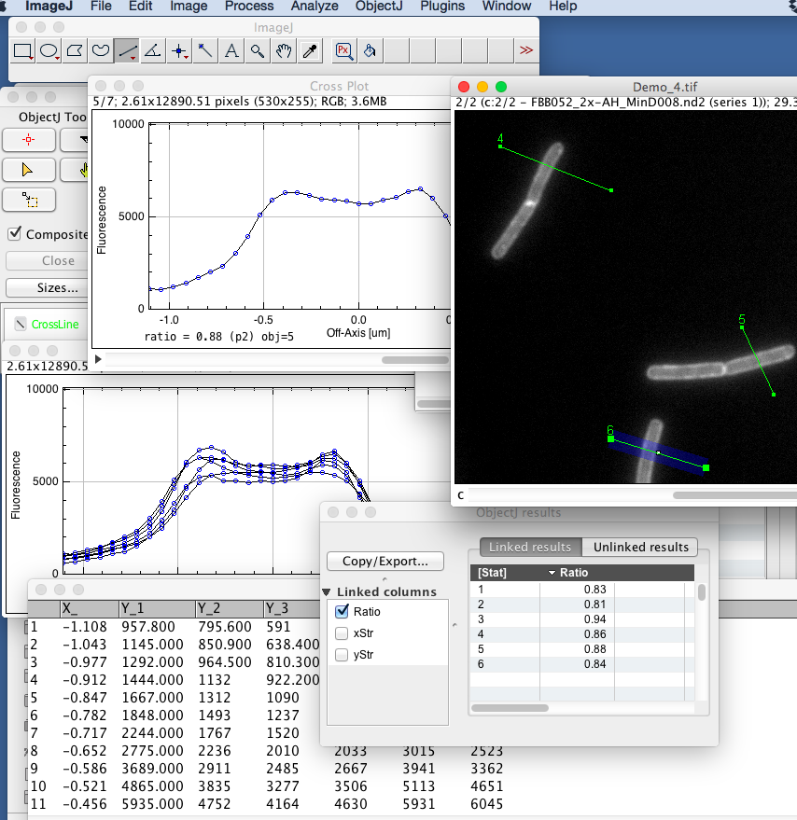

Measurement steps:

- Open CrossProfiles.ojj by dragging it into the ImageJ main window

- Open one of the linked images

- Choose Line tool and draw a line across a filament.

- Choose ObjectJ>Line Roi to Object[1] (or press key 1)
(green line object will be drawn in channel 2)
Linewidth will be adjusted (currently. 20 pixels).
The line tool will be re-activated

- Continue to set more lines on more linked images

- Choose ObjectJ>Save Project to save your measurements

- Choose ObjectJ> Analyze Profiles
this will create a stack of plots, with one extra plot with superimposition of all. Also the numerical results are calculated

- Plots are automatically centered so the cell axis is at x = 0

- The length and symmetry of the marked lines does not matter, but must be long enough so that the macro is able to detect the correct plot window which is 35 pixels wide (2.2 um), and the line should cover background for correct background subtraction (we subtract the lowest value of the line).

- The ratio between the higher of two peaks and the valley is given in ObjectJ results (e.g. 0.88). If there is no valley, the ratio is 1.0.. (Choose ObjectJ>Show ObjectJ Results)

- You also can export the individual profiles as raw data via ObjectJ>Export Qualified Profiles.

